# Ripple – Archetype and Templates June 2015

## A. Archetypes and Templates on UK CKM (clinicalmodels.org.uk/ckm)

### Templates

The images show the re-use of archetypes drawn from other UK CKM archetype owners e.g. medication , allergies, AoMRC headings, alongside local Ripple archetypes.

1. IDCR – Transfer of Care Summary

http://clinicalmodels.org.uk/ckm/#showTemplate_1051.57.44

<http://clinicalmodels.org.uk/ckm/#showTemplate_1051.57.52_ORGCHART>

1. IDCR – Cancer MDT Output Report

http://clinicalmodels.org.uk/ckm/#showTemplate_1051.57.52

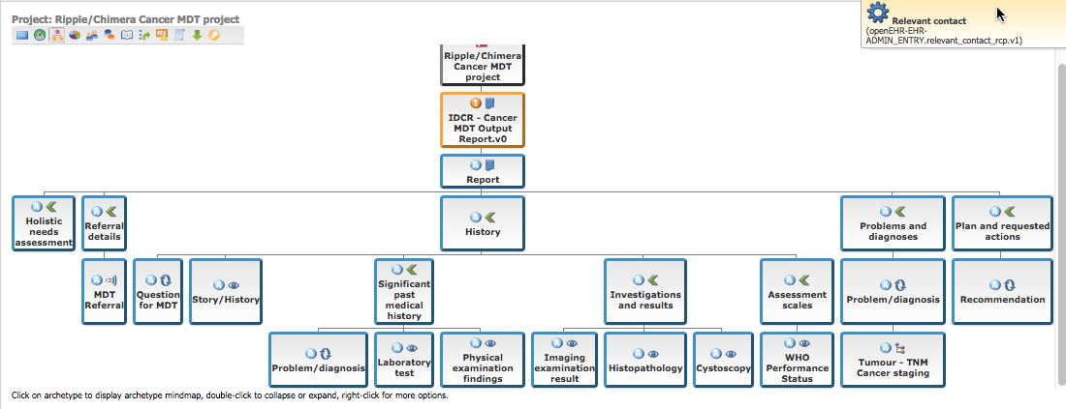

<http://clinicalmodels.org.uk/ckm/#showTemplate_1051.57.52>_ORGCHART

3. End of Life Care Coordination Document

http://clinicalmodels.org.uk/ckm/#showTemplate_1051.57.14

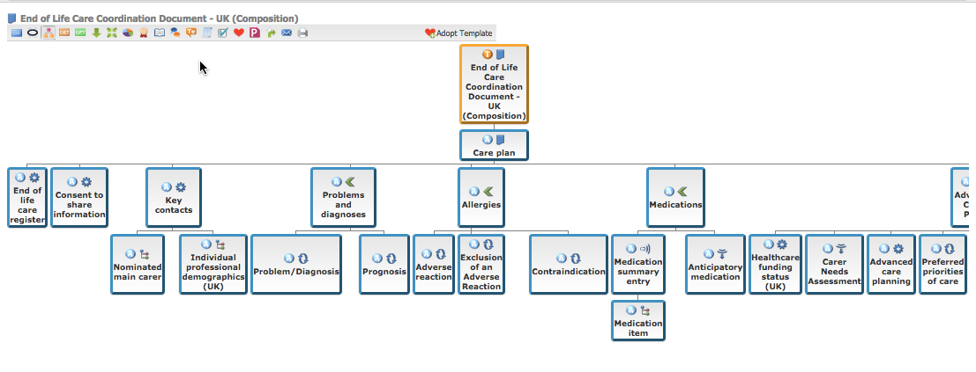

<http://clinicalmodels.org.uk/ckm/#showTemplate_1051.57.14>_ORG_CHART

### Archetypes

1. Inpatient admission, Draft Archetype [Internet]. UK Clinical Models, UK Clinical Models Clinical Knowledge Manager [cited: 2015-06-05]. Available from: http://clinicalmodels.org.uk/ckm/#showArchetype_1051.32.29
2. Relevant contact, Draft Archetype [Internet]. UK Clinical Models, UK Clinical Models Clinical Knowledge Manager [cited: 2015-06-05]. Available from: http://clinicalmodels.org.uk/ckm/#showArchetype_1051.32.293
3. WHO Performance Status, Draft Archetype [Internet]. UK Clinical Models, UK Clinical Models Clinical Knowledge Manager [cited: 2015-06-05]. Available from: http://clinicalmodels.org.uk/ckm/#showArchetype_1051.32.332
4. IPSS Prostate Score, Draft Archetype [Internet]. UK Clinical Models, UK Clinical Models Clinical Knowledge Manager [cited: 2015-06-05]. Available from: http://clinicalmodels.org.uk/ckm/#showArchetype_1051.32.333

## B. On Ripple private GitHub repository <https://github.com/handihealth/c4h_lcr_answer>

These (and associated archetypes) will be made public in due course.

### Templates

1. IDCR Allergies Encounter.v0
2. IDCR Allergies List.v0
3. IDCR Problem List.v0
4. DCR Problem Encounter.v0
5. IDCR Relevant Contacts List.v0
6. IDCR Medication List.v0
7. IDCR Handover Summary Report.v0